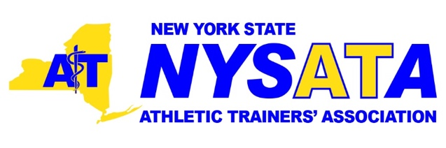

The NYSATA Conference Program Committee is assembling the programming for the 2021 NYSATA Annual Meeting and Clinical Symposia, to be held Friday June 11 - Saturday June 12, at the DoubleTree by Hilton in Schenectady, NY. Due to the COVID-19 pandemic, this conference may be virtual.

The NYSATA Conference Program Committee is dedicated to the development of an educational program designed to serve and advance the needs of our membership. We are committed to providing educational and professional experiences that expand the diverse skill and knowledge sets utilized daily by athletic trainers.

We welcome proposal submissions from NYSATA members and non-members for the following program formats:

General Lecture (1 hour presentation on original research, case study, clinical practice update, critically appraised topic or EBP content)

Hands-on Workshops (interactive format; presentation length between 1-5 hours)
All proposals are due for review by January 15, 2021

Proposal Submission Process: Proposed topics and format requests must fall within one of the five domains of practice for athletic training, and must contain advanced professional content considered beyond entry-level in order to be considered:

• Injury and Illness Prevention and Wellness Protection
• Examination, Assessment and Diagnosis
• Immediate and Emergency Care
• Therapeutic Intervention
• Healthcare Administration and Professional Responsibility

I. Project/Abstract Information:
Title of Proposed Presentation:
Domain of AT Practice: (Check all that apply)
___ Injury and Illness Prevention and Wellness Protection
___ Examination, Assessment and Diagnosis
___ Immediate and Emergency Care
___ Therapeutic Intervention
___ Healthcare Administration and Professional Responsibility

3 Keywords Describing Presentation Proposal:

Abstract (<350 Words):

Level of Content for Certified Athletic Trainers
___ Essential ___ Advanced ___ Mastery
Specific Learning Objectives (minimum of 3):
At the conclusion of this presentations, attendees will…

Nature of Presentation/Content
___ Case Study/Case Series ___ Experimental ___ Critically Appraised Topic (CAT)
___ Clinical Update ___ Professional Topic ___ Workshop ___ Other:
If “Other”, please describe the nature of your presentation:

Desired Presentation Format
___ General Lecture ___ Workshop

If this conference is moved to a virtual setting, would you be willing and able to present virtually?
___ Yes ___ No
If proposing a WORKSHOP, what equipment or resources will you need to deliver your program?

If proposing a WORKSHOP, how long do you need for completion (1-5 hours)?

Does your proposed project meet criteria for a BOC Approved EBP program?
___ Yes ___ No

Please indicate submission of both files below:
___ Blind Abstract Submission ___ Full unblind Abstract Submission

II. Speaker/Author Information:
Primary Author Name (Last, First)

Primary Author NATA Member #:
Primary Author NATA State membership:
Primary Author’s Phone #:

Author Status (at time of submission)
___ UG/Grad Student ___ Practicing Professional

Institutional Email of Primary Author:
Other Credentials? (i.e., PT, MD, etc.)
Current Professional Affiliation or Place of Employment:
Secondary Author Names & Credentials: (if applicable):
*Please attach a current copy/version of the Primary Author’s Curriculum Vitae/Resume

III. Proposal Deadline
All proposals are due for committee review by January 15, 2021. Final decisions will be determined by March 1, 2021 and communicated to primary authors shortly thereafter.

All presentations must avoid any affiliation with commercial products or service. Proposal selection is contingent upon approval by the Conference Program Committee. Incomplete (missing materials) or late applications will not be accepted.

Due to programming time constraints and the size of the convention facilities, not all proposals may be accepted. In this instance, proposals will be reviewed and selected by a proposal screening committee based on current years pre-approved programming, the quality of the content, organization of the meeting, equipment needs (when applicable), significance of the material to the NYSATA membership, and NYSATA/NATA membership status.

Proposals should be forwarded electronically to Aimee Brunelle, NYSATA Conference Chair at NYSATAconference@gmail.com. Please submit two (2) abstract files, both a “blind” copy with identifying author name(s) and institution(s) removed, and a full copy of your abstract with this completed cover sheet, and a current copy of your curriculum vitae/resume.

